Unit Repossession – Job Order Request

- Purpose

When a motorcycle unit is repossessed, it is likely that there are missing or broken parts. Prior to selling this unit, a Job Order Request needs to be accomplished to make the repossessed unit servicable.

- Views
  - List View
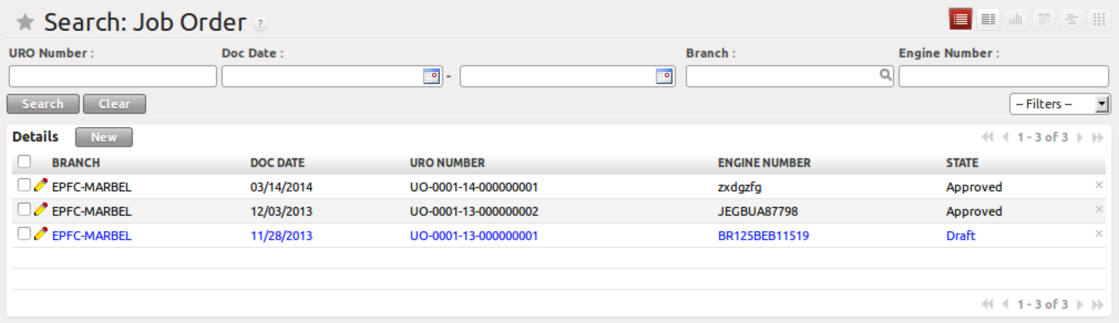
Figure 1. List view of Job Order Request

  - Form View
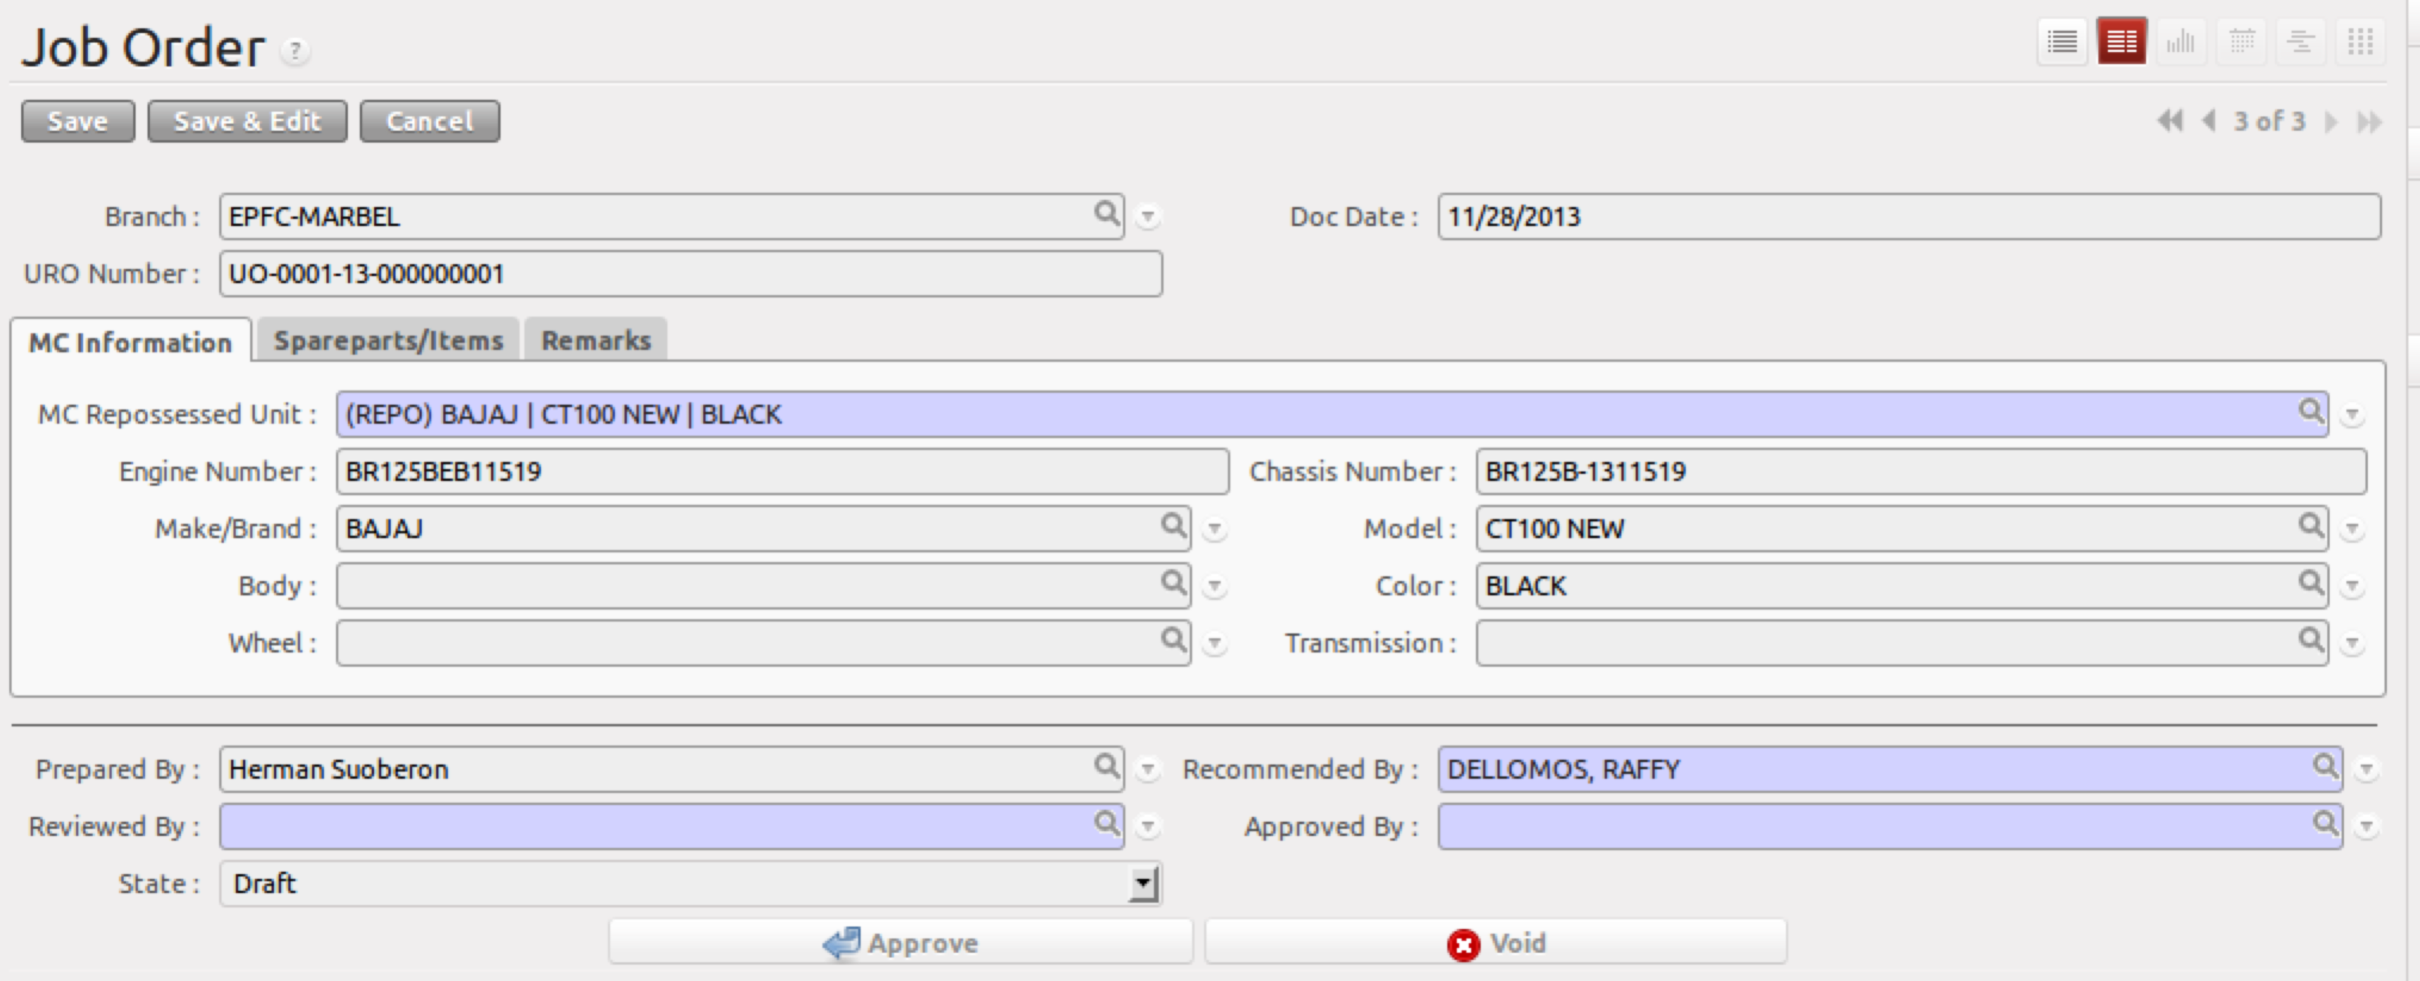
Figure 2. Form view of Job Order Request

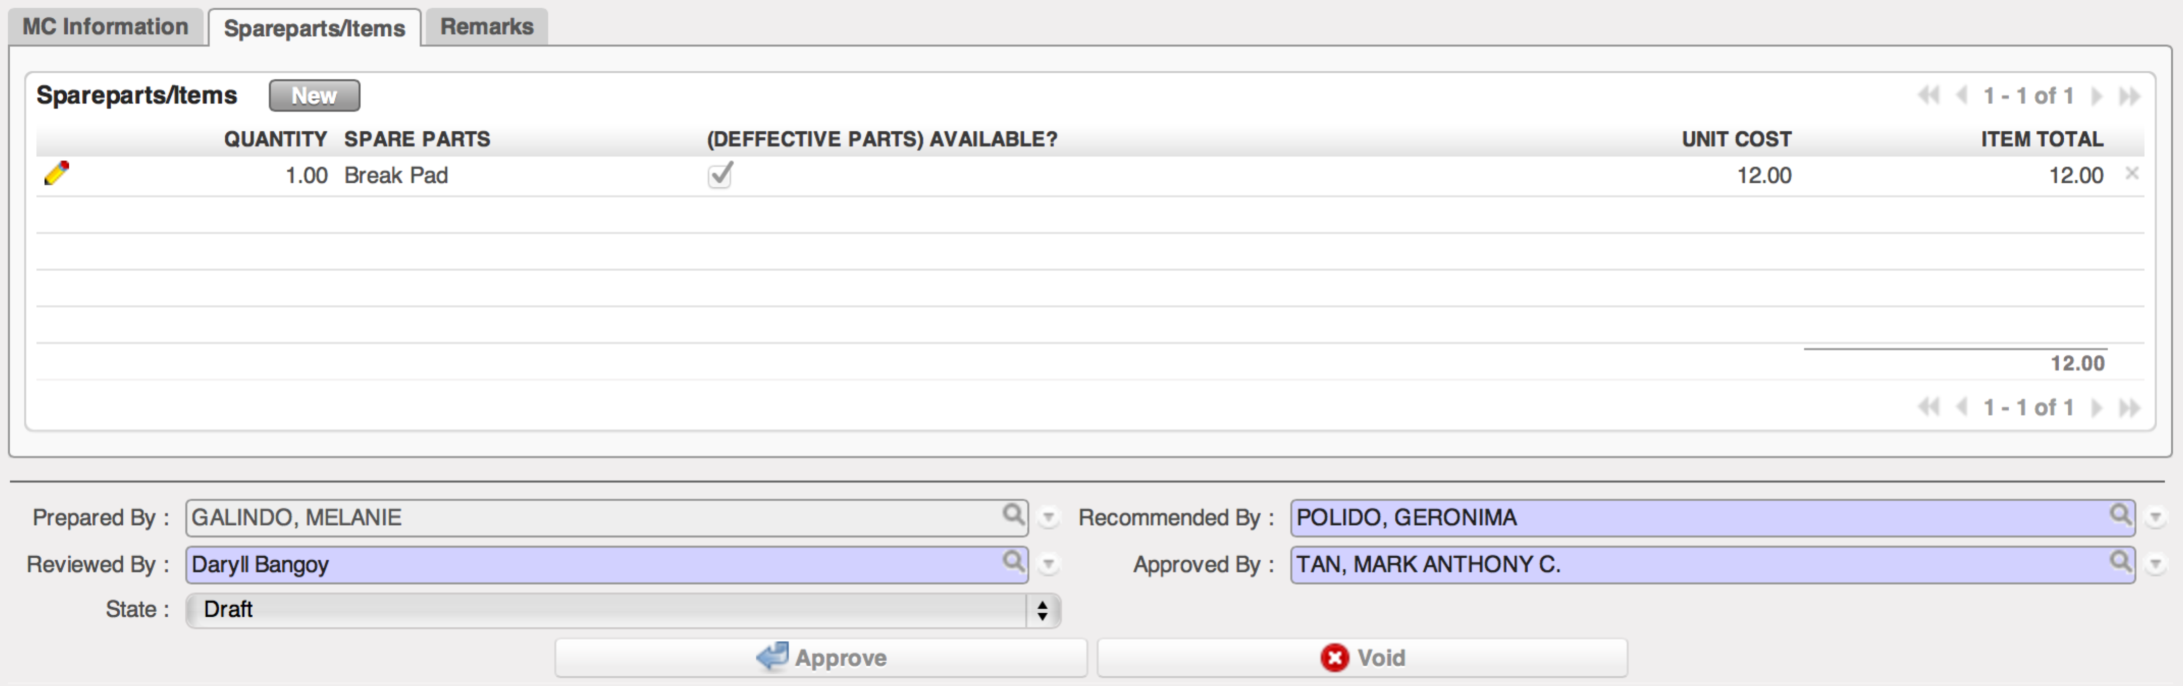
Figure 3. Spareparts/Items tab of Job Order Request
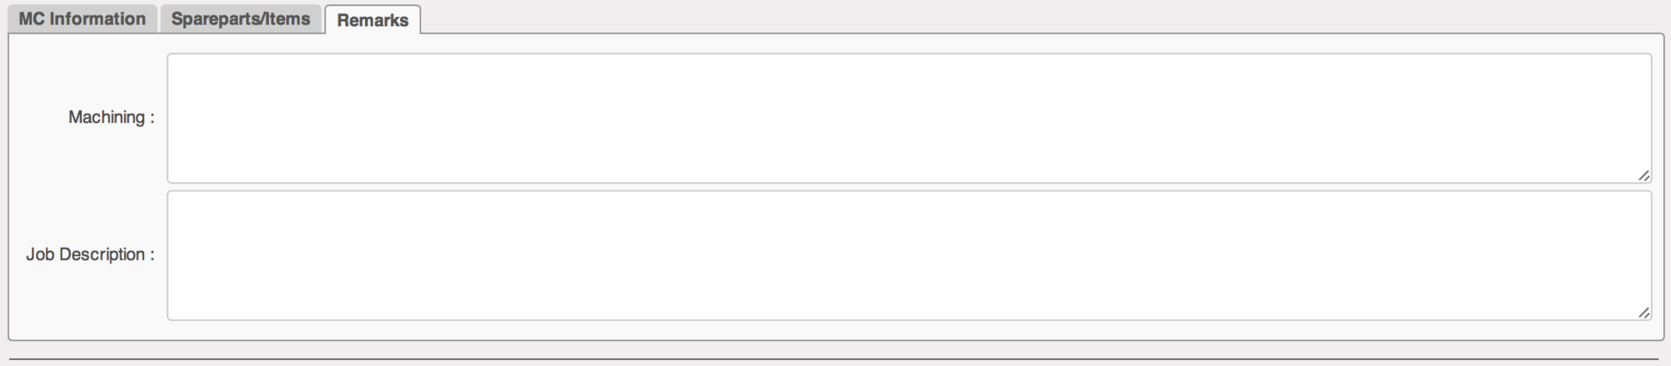
Figure 4. Remarks tab of Job Order Request

- Menu and Access Rights
  - Menu – Job Order > Request
  - Access Rights
Role | Read | Write | Create | Delete
Receptionist | Yes | Yes | Yes | No
Service Manager | Yes | Yes | No | No
Area Manager | Yes | Yes | Yes | No

- Required Fields
All required fields can be easily distinguished from the form view. These are the fields highlighted in Figure 2.

- Recommended By – Branch Manager
- Reviewed By – Service Manager
- Approved By – General Manager

- Workflow
Below is the list of states and visibility of the various buttons based on the record state:
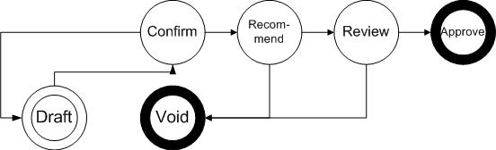
Figure 5. Workflow of Job Order Request

State | Description | Visible Buttons
Draft | Initial state of the record | Confirm
Confirmed | Record has been submitted for review and no further changes is expected. | Recommend
Recommended | Record has been recommended by the Branch manager | Review  Void
Reviewed | Record has been reviewed by the Service Manager | Approve  Void
Approved | Record has been approved by the Area Manager | No further actions
Void | Record has cancelled | No further actions

- User Action
Below is the list of user action available for specific users and its corresponding procedures:

Button | Action | Triggred By
Confirm | No Action | Receptionist
Recommend | No Action | Branch Manager
Review | No Action | Service Manager
Approve | No Action | Area Manager
Void | No Action | Branch Manager  Service Manager

- Field Visibility
All fields are visible to all users with read access to the record.

- Reports and Print Outs
